Prelab 6
Part 1: Background Knowledge
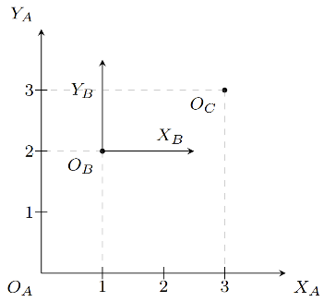
- What is the position of frame B with respect to frame A? Or in other words, what are the distances along X_{A} and Y_{A} from O_{A} to O_{B}?
O_{B} is at [1, 2] relative to O_{A}.
- What is the position of O_{C} relative to frame A?
O_{C} is at [3, 3] relative to frame A.
- What is the position of O_{C} relative to frame B?
O_{C} is at [2, 1] relative to frame B.
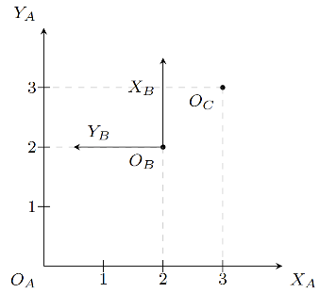
- What is the position of frame B with respect to frame A?
Frame B is at [2, 2] relative to frame A.
- What is the position of O_{C} relative to frame A?
O_{C} is at [3, 3] relative to frame A.
- What is the position of O_{C} relative to frame B?
O_{C} is at [1, -1] in (X_{B}, Y_{B}) relative to frame B.
- How would we rotate frame A to get the axes to align with frame B (X_{A} parallel to X_{B} and Y_{A} parallel to Y_{B})?
Frame A should be rotated 90 degrees counterclockwise about O_{A} to align with frame B.
Part 2: Expanding on Background Knowledge
- Based on this, for our previous example, what is the direction of the positive Z axis?
Based on the last question, the Z axis should be pointing out of the page, according to the right hand rule.

Reflection
The background knowledge about coordinate frames is critical to previsualizing robot programs and understanding how a robot will move. This is quite easy to understand on paper, as everything is relative to an origin, and different origins can be relative to each other. Rotations are more complex than translations, as they can occur about each axis in a coordinate system. A convention to make this easier to understand is the right hand rule, which dictates the direction of the Z-axis based on curling your right hand’s fingers. The fingers curl from X to Y, and the thumb points in the direction of the Z axis. This identifies whether a rotation is positive or negative, which makes it easy to notate rotations in code.

